Curriculum Goals 2024-2025 Oak Class

Settle In | Confident Child  Be a confident member of Oak class and a kind member of the class understanding our school values
Settle In | Independent Individual  Care for their own needs and look after their environment
Retell | Confident Communicator  Demonstrate good listening skills, ask questions to adults and peers, enjoy and retell a variety of stories and rhymes, share new vocabulary, create ‘Helicopter stories’, participate in whole school performance opportunities (Harvest, nativity, class assemblies etc)
Write | Wow Writer  Make marks with meaning, form letters and begin to write sentences in different contexts, that can be reread to a friend
Create | Master of Maths  Show a good understanding of numbers to 10, recognise patterns and play with number. Make up a maths game for friends to play
Investigate | Interested Investigator  Ask ‘how’ and ‘why’ questions of the natural world around them –hunt for bugs, observe different animals and watch a caterpillar change.
Grow | Great Gardener  Observe the seasons, explore plants around them and name parts, show awareness of healthy eating, role of worms, grow own vegetables to eat
Travel | Time Traveler  Explore local community, share holidays and different places around the world, create maps and share ‘Travelling Ted’
Make | Talented Tool User  Select and use simple tools safely(pencil sharpener, hole punch, scissors) create - develop – amend projects, practice different ways of joining materials together. Use woodworking tools with confidence and safely, using wood and objects to create

The goals are adaptable to the individual children in the cohort. Practitioners will offer scaffolding and extra support to help every child access the different milestones at their own pace as they progress through the year. Practitioners will sensitively reduce their support as they see children becoming more confident and independent in their learning.
If children move on quickly the emphasis will be on deepening their understanding rather than introducing new skills and concepts.
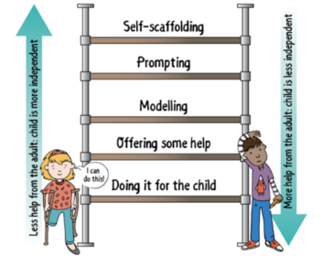
Image from Julian Grenier

School chickens

Harvest festival

Celebrations from different cultures (chinese new year, Dwali)

Parents who have a new baby to come in

Visiting pets – Tortoise/Hamsters

Visit to the park

Visit to Frensham ponds/beach

Visit to Durleighmasrsh for pick your own

Visit to the church

Over the year we will plan for progressively rich experiences within and beyond the school

World ‘?’ day/week celebrations

Visit to the libarary

Christmas nativity

Seasonal walks around village

Explore seasons

Planting vegetables

Weekly/fortnightly cooking

Butterfly lifecycle

Reading buddies with older children in school

Visit to William Stephens’
farm in Binsted

Parents and adults from local community visit to share their interests and jobs
Visit from community figures (fire/police/vicar)

Easter celebrations

Food tasting from different cultures

Litter walks

Our Phonics scheme is Early Letters and Sounds. We have daily phonic sessions as a whole class.
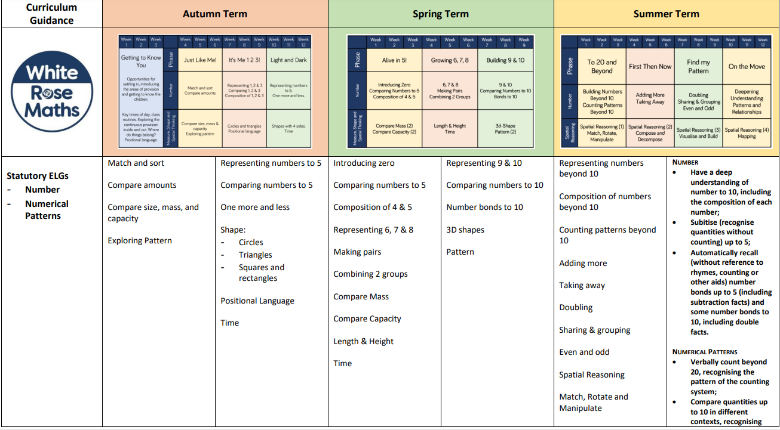
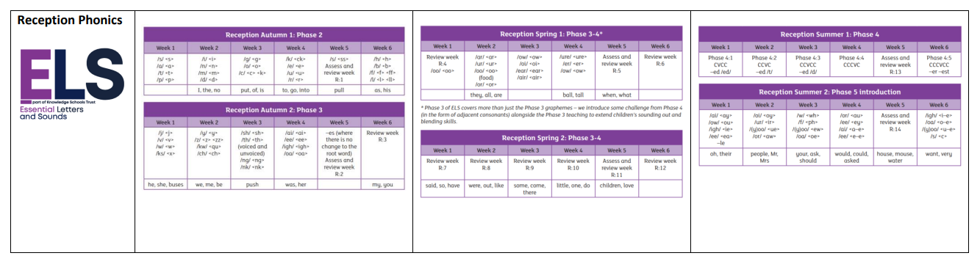
We use the White Rose maths scheme and adapt where relevant to the children’s learning and interests.

