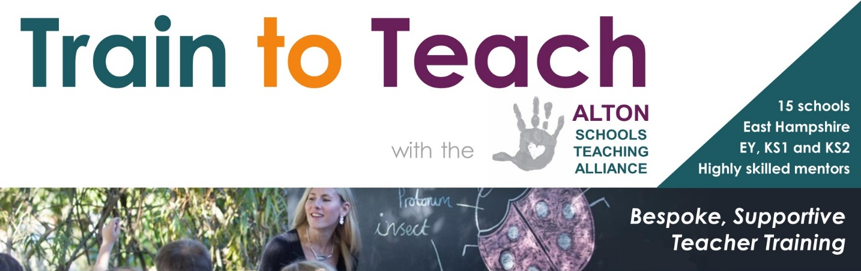
Teacher Training in Alton
To provide the best education to our children, we need teachers who are trained to the highest standards, who are creative, dedicated, empathetic and knowledgeable, whether they are new to the profession or experienced school staff, which is why Binsted CE Primary is proud to be part of the Alton Schools Teaching Alliance.

As an Alliance, the sole aim of the ASTA is to support, train and shape the teachers of today and tomorrow in Early Years and Primary education.

You could train to teach in our school!
​The Alton Schools Teaching Alliance is made up of 15 schools located in Alton and the surrounding villages in East Hampshire and covers 3 stages - Early years, KS1 and KS2. We offer a wide range of teaching experiences in Good and Outstanding; rural and town; infant, junior and all-through primary schools.
Our ITT programme is run in partnership with Winchester University, and offers the very best in bespoke, supportive teacher training to a select cohort. If you know of someone, or you yourself would be interested in training to teach, then please visit the ASTA website: www.altonschools.com or email us at info@altonschools.com.

The schools within the Alton Cluster of the FTSA are:
Alton Infant
Andrews' Endowed CofE Primary
Anstey Junior
Bentley CofE Primary
Binsted CofE Primary
Bushy Leaze Nursery
Chawton CofE Primary
Medstead CofE Primary
Rowledge CofE Primary - lead school for ASTA teacher training programme
Saint Lawrence CofE Primary
Selborne CofE Primary
St Mary's Bentworth CofE Primary
The Butts Primary
Wootey Infant
Wootey Junior

